Print default values of static & instance variables for different data types.

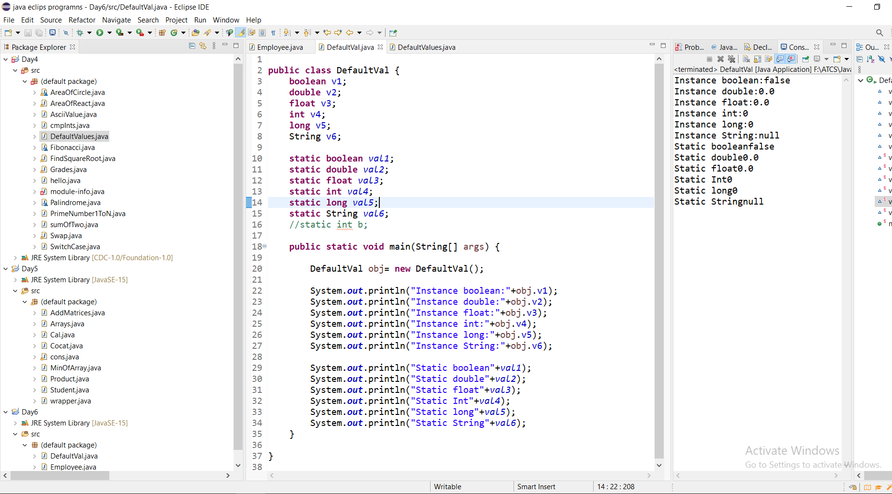

Build a class Employee which contains details about the employee and compile and run its instance.

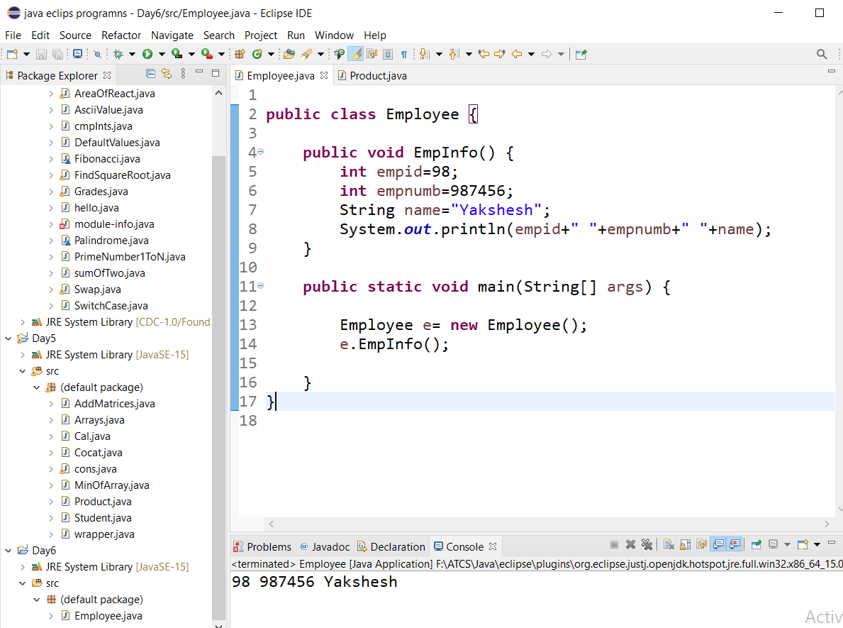

Build a class that has references to other classes. Instantiate these reference variables and invoke

(Call by Reference)

Create Student class with global variables and related methods with constructor and without constructor

observe the difference between methods calling and constructor calling

Create a class Vehicle and encapsulate the data members.

Create one Animal class(superclass), Dog class(subclass) the same method in the

Multilevel Inhertance

